Assignment 5: White-Box Evasion Attacks
CSC 592: Machine Learning Security and Privacy

Part 1: Literature Reading Questions

Instructions: Read section 1 and section 2 carefully from: “On Evaluating Adversarial Robustness” by Carlini et al. The e-print can be found here: https://arxiv.org/pdf/1902.06705. After reading answer the following questions:
R1. Carlini et al. specifically state that the $l_{p}$-norm constrained threat model does not often match real world threats. Why is it useful to study and experiment with the $l_{p}$-norm threat model then?
R2. What practices should an adversarial machine learning researcher follow to make sure their results can be replicated by others in the community?
R3. What are the three common reasons someone might be interested in evaluating the robustness of a machine learning model?

Part 2: Theory Questions

Instructions: Answer the following questions using 1-3 sentences or show the mathematical steps used to derive your answer when appropriate.

Q1. For a white-box evasion attack in adversarial machine learning, what knowledge does the attacker need to have?
Q2. In evasion attacks with images, why do we include a constraint ${\left\|x_{adv}-x\right\|}_{p}≤ϵ$?
Q3. In FGSM why do we move in the positive direction of the gradient?
Q4. Why is IFGSM often preferred over FGSM as an attack method?
Q5. What are the three reasons that the $l_{∞}$ norm is often used when measuring the distance between clean and adversarial examples?
Q6. Part A: Given a clean example $x=[1,2,3,4]$ and $x_{adv}=[1,5,7,9]$ what is the $l_{∞}$ distance between $x$ and $x_{adv}$? Show all steps used to get your answer.
Q6. Part B: Given a clean example $x=[1,2,3,4]$ and $x_{adv}=[1,5,7,9]$ what is the $l_{2}$ distance between $x$ and $x_{adv}$? Show all steps used to get your answer.
Q6. Part C: Given a clean example $x=[1,2,3,4]$ and $x_{adv}=[1,5,7,9]$ what is the $l_{0}$ distance between $x$ and $x_{adv}$? Show all steps used to get your answer.

Q7. Your friend Alice has written a code for IFGSM that does not include any projection operation and no randomized starting step. She is running the code with $ϵ_{max}=0.031$, $ϵ_{step}=0.05$ and $N=20$ (number of steps). Are there any issues with this approach? Explain why or why not.
Part 3: Comparing White-Box Evasion Attacks Code

Background
There are a number of different white-box evasion attacks that have been developed in the adversarial machine learning literature. In today’s assignment we will experiment with the Fast Gradient Sign Method (FGSM), Projected Gradient Descent (PGD) attack and the Carlini and Wagner (C&W) attack. If you are interested, the papers for each attack are given below (reading the papers is NOT required for this part of the assignment):
FGSM: https://arxiv.org/abs/1412.6572
PGD: https://arxiv.org/pdf/1706.06083
C&W: https://arxiv.org/abs/1608.04644
Step by Step Guide
Follow the instructions carefully step by step:
Step 1: Create a new Python project called “LabComparingAttacks” using the Integrated Development Environment (IDE) of your choice (e.g., Visual Studio, Visual Studio Code, PyCharm).
Step 2: Download and add three .py source files from Brightspace to your “LabComparingAttacks” Python project. The three source files are, “AttackWrappersWhiteBox.py”, “ResNet.py” and “DataManagerPytorchL.py”. Your project should contain the following files as shown in the screenshot below:
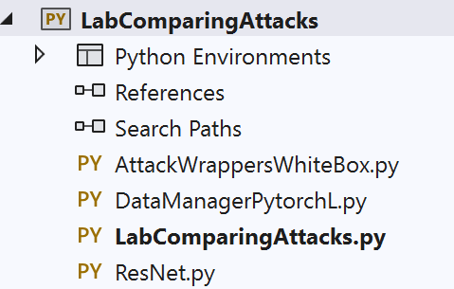
Note the “AttackWrappersWhiteBox.py” has been updated since the previous lab assignment. Make sure you download the latest version which contains the PGD and C&W attack methods. Likewise “DataManagerPytorchL.py” has also been updated so please make sure you download the latest version.
Step 3: Download the machine learning model we will be attacking from Brightspace. The model file is called “ModelResNet56-Run0.th”. Copy the file path of where the model is saved, as we will need it later. In Windows you can do this by right clicking on the model file, selecting properties, and then copying the value of the Location property. This is shown in the screenshot below:
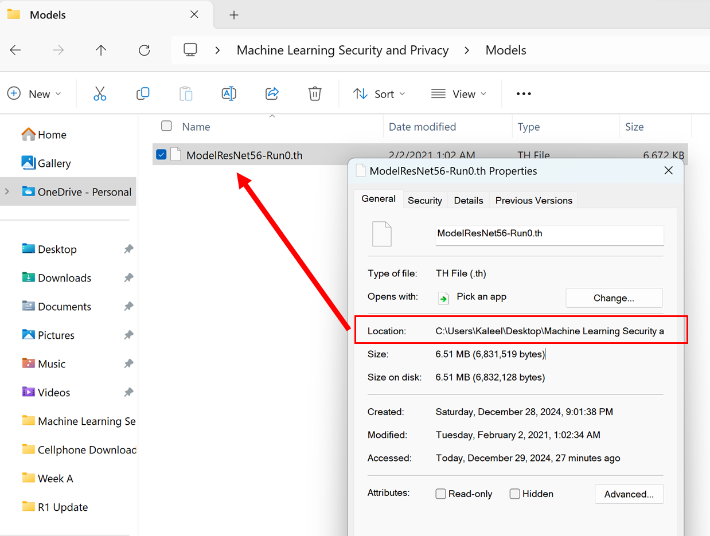
The ResNet is the same model from the previous assignment, it has not changed.
Step 4: The Carlini and Wagner attack requires one additional library to run called Foolbox. In Visual Studio this can be installed as follows. First go to pip and run the command, “pip install foolbox” as shown below:
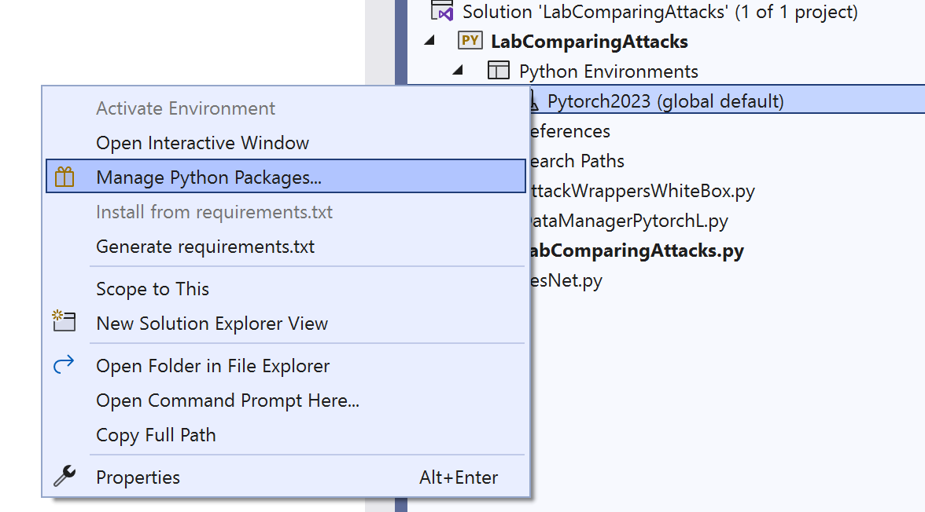
Click on “Manage Python Packages...” for the Python environment that you are currently working in.
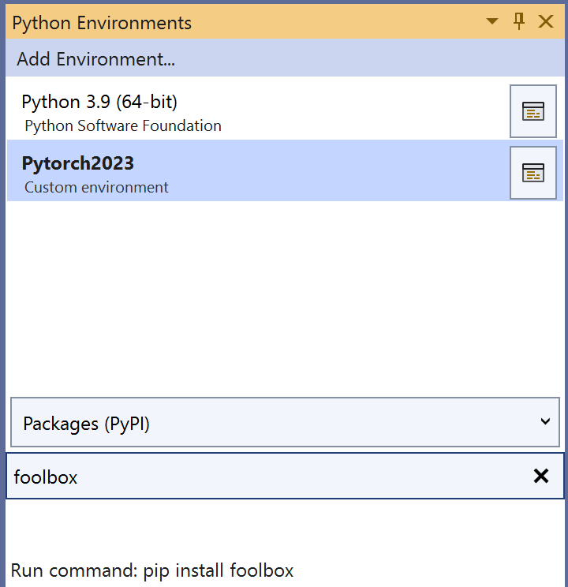
Type foolbox in the search window and then click on “Run command: pip install foolbox”.

Step 5: Go to the “LabComparingAttacks.py” file and copy the following code:
import torch
import DataManagerPytorchL as DMP
import AttackWrappersWhiteBox
import ResNet

def main():
#Replace the next line with the file path of where you saved the ResNet model
modelDir = "C://Users//Kaleel//Desktop//Machine Learning Security and Privacy//Models//ModelResNet56-Run0.th"
#Define the GPU device we are using
device = torch.device('cuda')
#Parameters for the dataset
batchSize = 64
numClasses = 10
inputImageSize = [1, 3, 32, 32] #Batch size, color channel, height, width
#Create the ResNet model (note this does not include pre-trained weights)
model = ResNet.resnet56(inputImageSize, numClasses).to(device)
#Next load in the trained weights of the model
checkpoint = torch.load(modelDir)
model.load_state_dict(checkpoint['state_dict'])
#Switch the model into eval model for testing
model = model.eval()
#Load in the dataset
valLoader = DMP.GetCIFAR10Validation(inputImageSize[2], batchSize)
#Check the clean accuracy of the model
cleanAcc = DMP.validateD(valLoader, model, device)
print("CIFAR-10 Clean Val Loader Acc:", cleanAcc)
#Get correctly classified, classwise balanced samples to do the attack
totalSamplesRequired = 10
correctLoader = DMP.GetCorrectlyIdentifiedSamplesBalanced(model, totalSamplesRequired, valLoader, numClasses)
#Check to make sure the accuracy is 100% on the correct loader
correctAcc = DMP.validateD(correctLoader, model, device)
print("CIFAR-10 Clean Correct Loader Acc:", correctAcc)
#Do the attacks
epsilonMax = 0.031 #Maximum perturbation
clipMin = 0.0 #Minimum value a pixel can take
clipMax = 1.0 #Maximum value a pixel can take
numSteps = 10
epsilonStep = epsilonMax/numSteps
#Run the attacks
advLoader = AttackWrappersWhiteBox.FGSMNativePytorch(device, correctLoader, model, epsilonMax, clipMin, clipMax)
#advLoader = AttackWrappersWhiteBox.PGDNativePytorch(device, correctLoader, model, epsilonMax, epsilonStep, numSteps, clipMin, clipMax)
#advLoader = AttackWrappersWhiteBox.CWAttackUntargetedFoolBox(device, correctLoader, model, clipMin, clipMax)
advAcc = DMP.validateD(advLoader, model, device)
print("CIFAR-10 Adv Acc:", advAcc)
xCleanTensor, yCleaTensor = DMP.DataLoaderToTensor(correctLoader)
xAdvTensor, _ = DMP.DataLoaderToTensor(advLoader)
DMP.ShowImages(xCleanTensor, xAdvTensor)

if __name__ == "__main__":
main()
Step 6: Recall that in step 3 you were asked to note down the file path of where you saved “ModelResNet56-Run0.th”. In the main function, replace the modelDir value with the file path where you saved “ModelResNet56-Run0.th”. For Professor Kaleel the file path looks like:
C://Users//Kaleel//Desktop//Machine Learning Security and Privacy//Models//ModelResNet56-Run0.th
Step 7: Read the code carefully to understand what is being run. The current code is set up to run FGSM on 10 clean, class-wise balanced, correctly identified samples from the CIFAR-10 validation dataset. The code then checks the class label that the ResNet-56 outputs for each adversarial example and reports the robustness. Lastly, the clean examples are displayed in the first row and the adversarial examples are displayed in the second row. Run the code. Your output should match what is displayed below:
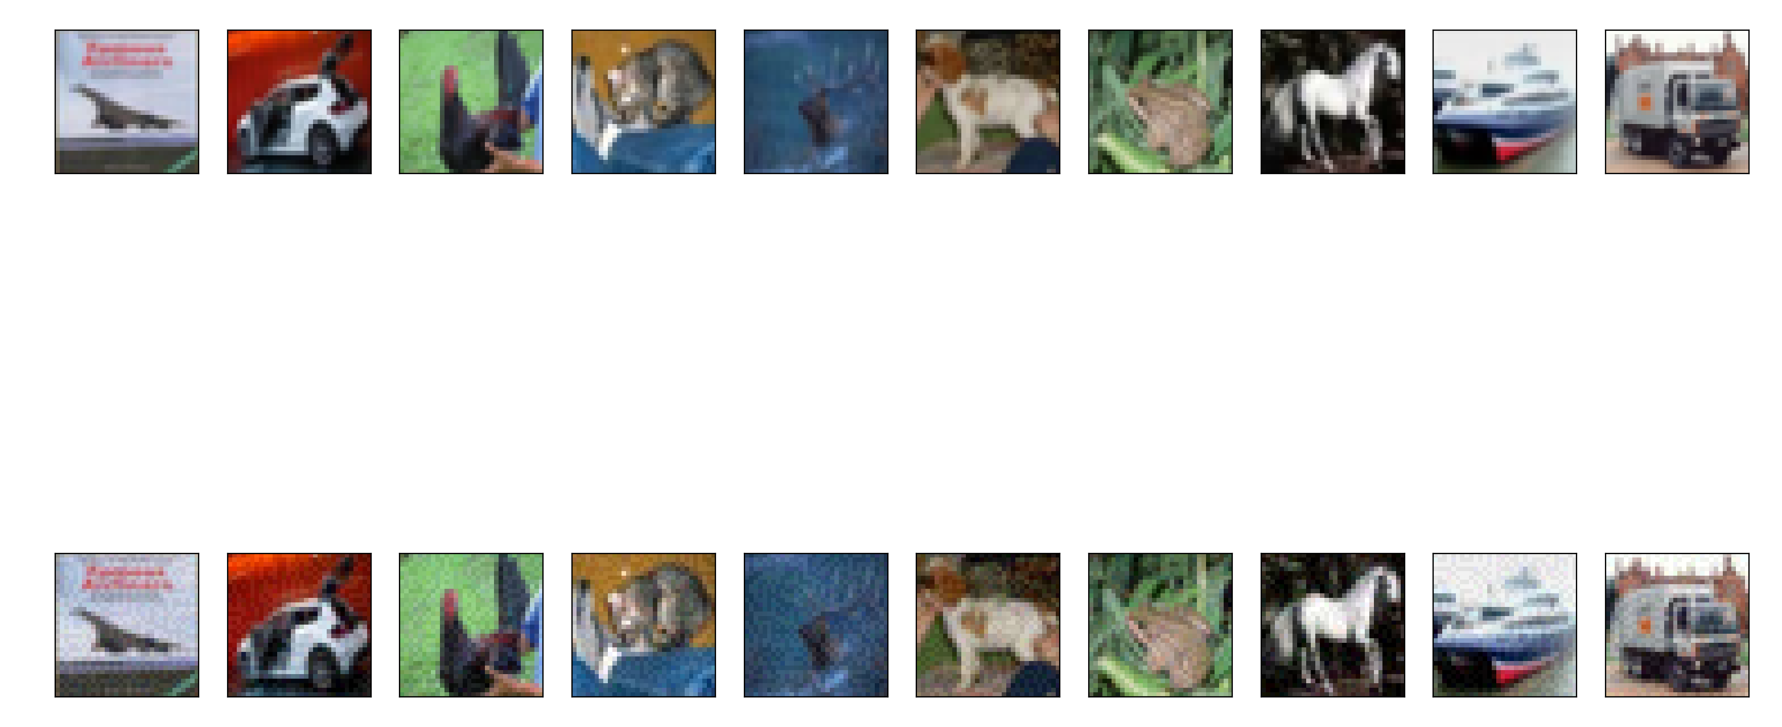
Files already downloaded and verified
CIFAR-10 Clean Val Loader Acc: 0.9277
CIFAR-10 Clean Correct Loader Acc: 1.0
Processing up to sample= 10
CIFAR-10 Adv Acc: 0.3
- Note you may need to maximize the window to see larger versions of the images.
Code Questions
Exercise 1: Run the code with the FGSM attack and epsilonMax = 0.031. Record the output of the code (both the images and the output from the terminal).
Exercise 2: Run the PGD attack by commenting out the following line of code in “LabComparingAttacks”:
advLoader = AttackWrappersWhiteBox.FGSMNativePytorch(device, correctLoader, model, epsilonMax, clipMin, clipMax)

And uncommenting the following line:
#advLoader = AttackWrappersWhiteBox.PGDNativePytorch(device, correctLoader, model, epsilonMax, epsilonStep, numSteps, clipMin, clipMax)

Record the output of the code (both the images and the output from the terminal).
Exercise 3: Run the C&W attack by commenting out the following line of code in “LabComparingAttacks”:
advLoader = AttackWrappersWhiteBox.PGDNativePytorch(device, correctLoader, model, epsilonMax, epsilonStep, numSteps, clipMin, clipMax)

And uncommenting the following line:
#advLoader = AttackWrappersWhiteBox.CWAttackUntargetedFoolBox(device, correctLoader, model, clipMin, clipMax)

Note this attack may take some time to run. Record the output of the code (both the images and the output from the terminal).
Exercise 4: Visually inspect the images from the three attacks (FGSM, PGD and C&W). Which attack had the most visible perturbation? Which attack(s) were most effective?
Exercise 5: Repeat exercises 1-3 with epsilonMax = 0.062. What differences do you notice in terms of perturbation on the images and attack performance? Did the C&W results change between exercise 4 and exercise 5?
Exercise 6: In the “AttackWrappersWhiteBox.py” file in the PGDNativePytorch function, which line of code corresponds to the main PGD equation:
$x_{adv}^{(i+1)}=x_{adv}^{(i)}+ϵ_{step}∙sign\left(\frac{∂L}{∂x_{adv}^{(i)}}\right)$?
Exercise 7: In the C&W attack, we optimize over $\frac{1}{2}(\tanh\left(w\right)+1)$ to make sure that $x+δ$ is bounded between 0 and 1. In the PGDNativePytorch function, which line of code ensures that $x+δ$ never exceeds 1 or goes below 0? Why do we want to maintain a certain range for $x+δ$?
Deliverables
Submit the following two items on Brightspace:
Deliverable #1: A document containing the answers to the questions from parts 1, 2 and 3 of the assignment.
Deliverable #2: A copy of your code in part 3 (the .py files).

